PRACTICE Challenge 01

# **Set Up:**

## Directory

Create a working directory & set up your base files & jQuery.

**Folder Name: challenge01**

* c01.html
* c01.css
* c01.js
* jquery-3.3.1.js (download and add to the folder)

At the end of your class, zip up this directory and submit on blackboard.

## Assets

Use FontAwesome to initiate a set of icons

* Icons: <https://fontawesome.com/v4.7.0/icons/>
* CDN: <https://stackpath.bootstrapcdn.com/font-awesome/4.7.0/css/font-awesome.min.css>

Use jQuery

* Download: <https://jquery.com/download/>
* Docs: <https://api.jquery.com/>

## OVERVIEW:

The purpose of this assessment is for you to demonstrate your Javascript & jQuery knowledge by building a simple web app.

There are two possible challenges, of which one will be allocated to you by your trainer. The challenge must be completed by the conclusion of the class and demonstrated in class.

# **CHALLENGE A: Click THE LOGO**

This challenge requires you to create a game board, covered with random icons. The player must click on as many matching icons as they can within 30 seconds. After 30 seconds the round ends and the score will be displayed to the user.

## Part 1:

* Create a layout similar to the one below (colours and sizes are your choice)
* Allow player 1 and player 2 to enter their names and display their name along with their score
* Create a start game button which generates the game board
* Create a re-start game button which clears the game board and starts a new game

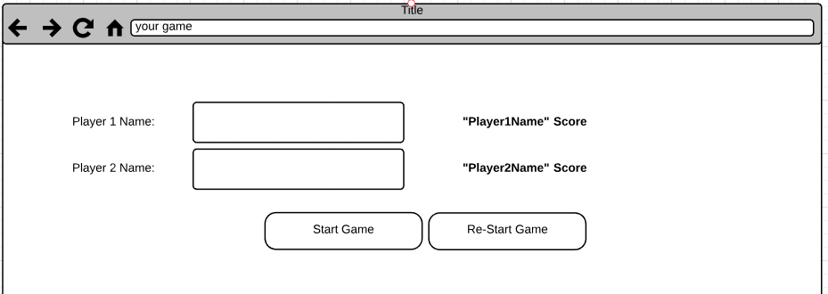

### What’s Being Assessed:

|  |  |  |
| --- | --- | --- |
| **Item** |  | **Satisfactory / Not Yet Satisfactory** |
| jQuery ID Selector | Select the inputs by ID |  |
| jQuery .click() | Bind a click event using jQuery |  |
| CSS | Reasonable layout and styles |  |
| HTML | Reasonable layout and styles |  |

## Part 2:

* Create a game board 10 x 10 cells
* In each cell create a random icon from a set of 10 possible icons (your choice)
  + Note: please use font awesome for the icons
* Create a message which notifies the player it is their turn by name

|  |  |  |
| --- | --- | --- |
| **Item** |  | **Satisfactory / Not Yet Satisfactory** |
| jQuery .val() | Getting the value of inputs |  |
| jQuery .html() | Changing the value of divs & tables |  |
| Javascript for loop | Using a for loop to create a grid layout for the board |  |
| Javascript Math.random() | Using a random number to select one of 10 possible icons |  |
| Javascript array | Setting an icon class based on a random number in an array |  |

## Part 3:

* Give one point for each matching icon a player clicks on
* End the turn if a player clicks on a non-matching icon
* Change the colour of an icon after it has been clicked on
* A player can play until they run out of icons to click on
* Display the players score at the end of the turn or as they click (your choice)

|  |  |  |
| --- | --- | --- |
| **Item** |  | **Satisfactory / Not Yet Satisfactory** |
| jQuery .on | Click events on dynamically generated HTML |  |
| .hasClass | Storage of last clicked icon and detection of icon |  |
| .css() or .addClass | Change the css or class of an icon when clicked |  |

## Part 4: *BONUS*

This section is not mandatory but encouraged if you have the time and opportunity to complete.

* Add a turn timer
* Add a win/loss screen (once all icons have been clicked at least once)

|  |  |  |
| --- | --- | --- |
| **Item** |  | **Satisfactory / Not Yet Satisfactory** |
| Javascript timeout() | Create a countdown timer that ends the turn after a period of time |  |
| jQuery .hide() .show() | Show and hide the win loss screen |  |
|  |  |  |